TOP 5 Reasons to Advertise on Facebook

Reason #1. Facebook Advertising is Highly Effective
No one would have guessed in 2004 that Facebook would become what it is today. With more than 2.2 billion monthly active and close to 1.5 billion daily active users, Facebook is a major part of people’s lives. This is a trend that is not going to change any time soon as we continue to ride the waves of the information era.
Facebook is considered one of the top advertising channels online, and digital ad spend accounts for a whopping 51% of total advertising spend in the US. If you are not sure whether Facebook ads will work for you, just let the data speak for itself:
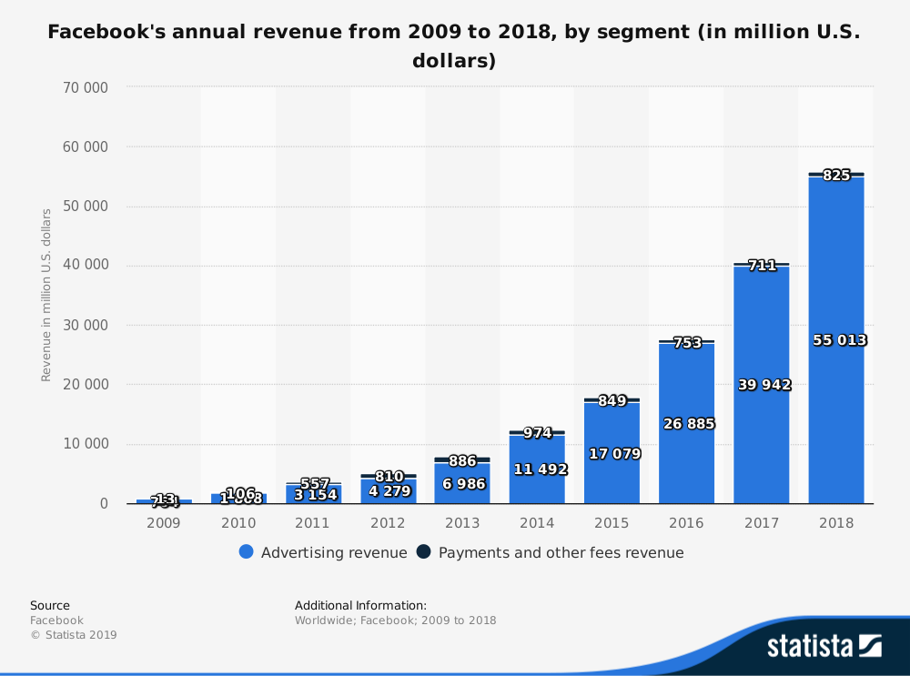
Facebook has seen a steady increase of advertising revenue year over year in the last decade because Facebook ads work. In a survey by Kleiner Perkins, it was found that 78% of American consumers say they’ve discovered products on Facebook.
Facebook ads can work for you, too, if you take the time to master the complex art that is creating highly effective Facebook ads.
As of June 2018, 55.1% of the world’s population has internet access, so the potential for growth on Facebook is great now and into the future as more people gain internet access and join Facebook. Facebook and the internet as a whole will continue to be the best way for you to connect with consumers and generate sales using ads.

Reason #2. Simple Set-Up Process and Fast Results
Setting up a Facebook campaign takes little time and can yield excellent results for your business. It is an undeniable truth that digital advertising produces a great ROI and it can happen very quickly with the right campaign and product. That is why you see Facebook ads for small local businesses as well as large corporations.
Anyone can log on to Facebook and create a business manager account, set a payment method and publish a campaign in a matter of minutes. You can even experiment with your campaign to find the lowest possible cost per lead through ad creation tools such as AdEspresso.
The following chart shows variations in CPC (cost per click) throughout the year on different placements using data from 2017. The Instagram placement had a CPC of $1.15 in Q4 2017 while desktop newsfeed placement in the same quarter had a CPC of only about $.50.
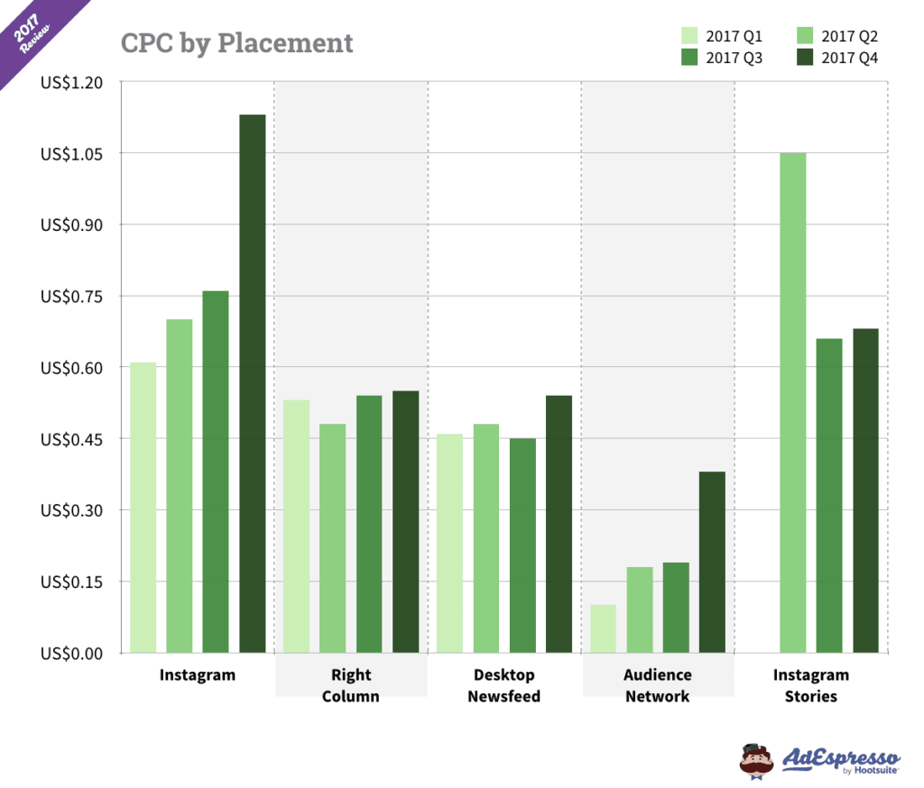
We can see that you can start driving traffic to your website starting at .10 cents a click. You don’t need an extraordinarily large budget to get started, and compared to running ads on other digital channels such as Google getting started with Facebook ads is quite simple.
You can boost a single post to reach users directly from your Facebook page, or you can create a more complex campaign that targets custom audiences and produces even greater results with the business manager.
After this guide, you’ll be confident on how to use business manager to create a winning Facebook campaign.

Reason #3. You Can Reach Your Ideal Audience
We’ve already touched on just how many people use Facebook every day, so is it any surprise that it is a great way to reach your ideal audience? Facebook provides tons of detailed ways to reach specific people based on their behavior on your website, their known likes, engagement with your Facebook page, and other various elements of their demographic such as age, gender, and location. You can create extremely granular audiences that produce a high ROI using Facebook ads.
In a 2017 study, it was found that 57% of consumers say that social media influences their shopping. Out of that 57%, 44% said that Facebook of all social media platforms was most influential.
With the targeting options available to you as an advertiser and the influence Facebook has on consumer behavior, Facebook is the perfect channel for reaching your ideal audience.

Reason # 4. Facebook Ad Campaigns Are Highly Customizable
You can construct the perfect ad experience using Facebook ads. Contrary to another big name in the digital ad space, Google, your Facebook ad experience can be designed to attract your perfect audience. That is because Facebook has a wide range of ad formats to choose from.
You can create a compelling video ad that millennial dog owners can’t resist watching, or an immersive canvas ad for senior citizen dog owners that explain every detail and benefit of your dog food product, for example. We will explore in depth the different Facebook ad types in Chapter 4 of this guide, but let’s have a look at how many campaign objective options there are:
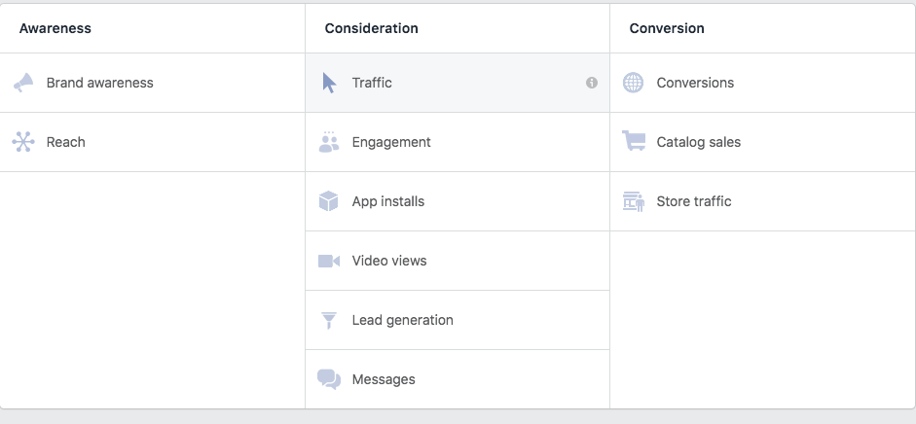
That’s 11 different Facebook ad objectives you can choose from based on your different goals. You can customize your ad design, copy, landing pages and virtually every element of the campaign including technical aspects such as:
Target audience
Bidding
Delivery optimization

These options make Facebook the most customizable advertising network, allowing you to create very specific ad experiences.

Reason # 5. Facebook Is Adding New Features Every Month
Facebook is constantly adding more features and improving user experience for both advertisers and normal Facebook users. This is a large part of why Facebook has sustained growth for so long, it’s always providing more value.
In 2018, we saw many changes on the platform that impact advertisers from new carousel ads for Instagram stories to categories for dynamic ads. With all of these Facebook updates, we can expect that Facebook continues to make their ad network more powerful and easier to use.
The faster you learn to advertise on Facebook, the sooner you’ll unlock the full potential of social media advertising. The best way to start learning about Facebook ads as a beginner is to just set up your Facebook Business Manager account and get in there and create your campaign!

